EXT: Campaign contents
Extension Key: campaign content
Language: en
Keywords: AB Testing
Copyright 2000-2010, Tolleiv Nietsch, <info@tolleiv.de>

This document is published under the Open Content License
available from http://www.opencontent.org/opl.shtml

The content of this document is related to TYPO3
- a GNU/GPL CMS/Framework available from www.typo3.org
Table of Contents

EXT: Campaign contents 1
Introduction 3
What does it do? 3
Users manual 4
Content-element A/B 4
Page Template A/B 5
Administration 6
Configuration 7
mod_rewrite Example 7
TypoScript Example 8
TSConfig Example 9
Appendix 10
To-Do list 11
ChangeLog 12

Introduction

What does it do?
- Enables to show/hide content depending on a specific “active” campaign
- The purpose is to enhance A/B testing capabilities and

Users manual

Content-element A/B
Each content element has a selector box which enables a content-element specific setup
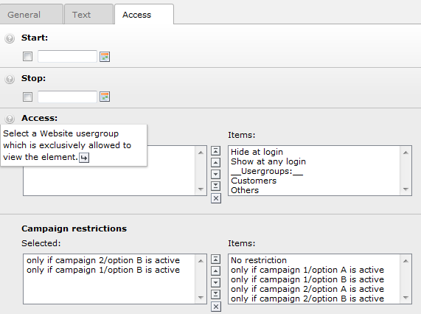
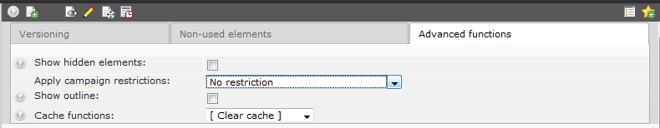
Within the page module you'll also find a selectbox where you can filter the elements in the pagemodule to see which elements are active in certain situations:

To preview the results of your settings just append the following query string to your url:
http://www.example.com/mypage.html?C1=A
The required “names” for this can be found within the configuration – see configuration.

Page Template A/B
Once the configuration is done setting up a new page template test is easy. Just create a sub-template for an existing page-template and select the related rendering option for that element.
- The easiest way to create a new template option is to copy an existing page template
  - Open the context-menu click “Copy”, reopen the context menu and click “Paste”
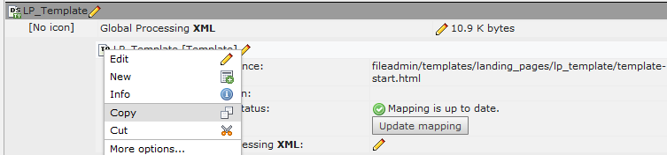
- Edit the new template by (e.g. click context-menu “Edit”)
- Change this template to be a sub-template of your original template. (This will reload the editing form).

- Setup when the template should be rendered

Once you've completed these steps TYPO3 will automatically choose the right template depending on your “page.10.childTemplate” setting (see configuration) – if no alternative template can be found the master template is rendered.

Administration
- Install and configure it – nothing else to do from an administrative standpoint

Configuration
- There are 3 places which need to be “ready” to run the suggested setup
- mod_rewrite – determines which campaign to use with a cookie, request and an environment variable
- typoscript – reads the environment variable and configures the right options for the filter operation
- Tsconfig – provides the relevant campaign options for the selectorbox of the elements.
Before configuring any of the following things you should find a clear naming for the current oampaign and their options. Within the examples the campaign is just named “C1” and the options are “A” and “B”. The configuration itself is host dependent. Within the examples the used host is “chaos.fondsvermittlung24.net”
The examples cover “only” campaigns with two options (true A/B) – within the appendix you'll find all the block also for A/B/C and A/B/C/D.

mod_rewrite Example
Suggested mod_rewrite setup:
############### CAMPAIGN 1 A/B INDICATOR ##############
# SAVE CURRENT COOKIE VALUE - SKIP NEXT RULES IF CONDITION MATCHED
RewriteCond %{QUERY_STRING} C1=(A|B)
RewriteRule .* - [E=C1:%1,NE,CO=C1:%1:chaos.fondsvermittlung24.net:1440:/,S=3]

RewriteCond %{HTTP_COOKIE} C1=(A|B)
RewriteRule .* - [E=C1:%1,NE,CO=C1:%1:chaos.fondsvermittlung24.net:1440:/,S=2]

RewriteCond %{HTTP_COOKIE} !C1=(A|B)
RewriteCond %{HTTP_REFERER} !.*chaos.fondsvermittlung24.net.*
RewriteCond %{TIME_SEC} ^[0-9][0|2|4|6|8]
RewriteCond %{QUERY_STRING} ^(.*)$
RewriteRule (.*) $1?C1=A&%1 [E=C1:A,NE,CO=C1:A:chaos.fondsvermittlung24.net:1440:/,S=1]

RewriteCond %{HTTP_COOKIE} !C1=(A|B)
RewriteCond %{HTTP_REFERER} !.*chaos.fondsvermittlung24.net.*
RewriteCond %{QUERY_STRING} ^(.*)$
RewriteRule (.*) $1?C1=B&%1 [E=C1:B,NE,CO=C1:B:chaos.fondsvermittlung24.net:1440:/]
############### CAMPAIGN 1 A/B INDICATOR ##############

To create a new campaign copy the block above, replace campaign name, option names and the host and place it in your .htaccess right after existing A/B blocks or at least right AFTER:
RewriteEngine On
Options +FollowSymLinks

TypoScript Example
The extension doesn't insert and default TypoScript to avoid overhead. Due to that the initial call to “check” the elements needs to be inserted too:
includeLibs.campaigncontent = EXT:campaign_content/classes/class.tx_campaigncontent_rendercond.php
tt_content.if.isTrue = TEXT
tt_content.if.isTrue {
field = uid
postUserFunc = tx_campaigncontent_rendercond->checkElement
postUserFunc.availableOptions {
C1 = A,B
}
}
### setup for CAMPAIGN 1 ###
[globalVar = GP:C1=B] || [globalString = HTTP_COOKIE_VARS | C1=B] && [globalVar = GP:C1!=A]
page.10.childTemplate = C1_B
tt_content.if.isTrue.postUserFunc.activeOptions.C1 = B
[else]
tt_content.if.isTrue.postUserFunc.activeOptions.C1 = A
[end]
Adding a new campaign requires two steps here:
- adding your campaigns and options to the list of available options,
e.g. change:
postUserFunc.availableOptions {
C1 = A,B
}
to:
postUserFunc.availableOptions {
C1 = A,B
- C2 = A,B
}
- configure how to acutally use the options – e.g by adding this block:
### setup for CAMPAIGN 2 ###
[globalVar = GP:C2=B] || [globalString = HTTP_COOKIE_VARS | C2=B] && [globalVar = GP:C2!=A]
page.10.childTemplate = C2_B
tt_content.if.isTrue.postUserFunc.activeOptions.C2 = B
[else]
tt_content.if.isTrue.postUserFunc.activeOptions.C2 = A
[end]

TSConfig Example
To have all the options which you want to process by TypoScript available in the relevant selectbox you've to add the following TSConfig to your pages:
TCEFORM {
tt_content {
tx_campaigncontent_restricttocampaign.addItems {
C1_A=only if campaign 1/option A is active
C1_B=only if campaign 1/option B is active
}
}
}

TCEFORM.tx_templavoila_tmplobj.rendertype {
addItems {
C1_A = A/B Testing campaign 1 version A
C1_B = A/B Testing campaign 1 version B
}
}

Appendix

A/B/C Blocks
mod_rewrite:
############### CAMPAIGN 1 A/B/C INDICATOR ##############
# SAVE CURRENT COOKIE VALUE - SKIP NEXT RULES IF CONDITION MATCHED
RewriteCond %{QUERY_STRING} C1=(A|B|C)
RewriteRule .* - [E=C1:%1,NE,CO=C1:%1:chaos.fondsvermittlung24.net:1440:/,S=4]

RewriteCond %{HTTP_COOKIE} C1=(A|B|C)
RewriteRule .* - [E=C1:%1,NE,CO=C1:%1:chaos.fondsvermittlung24.net:1440:/,S=3]

RewriteCond %{HTTP_COOKIE} !C1=(A|B|C)
RewriteCond %{HTTP_REFERER} !.*chaos.fondsvermittlung24.net.*
RewriteCond %{TIME_SEC} ^[0-9][0-3]
RewriteCond %{QUERY_STRING} ^(.*)$
RewriteRule (.*) $1?C1=A&%1 [E=C1:A,NE,CO=C1:A:chaos.fondsvermittlung24.net:1440:/,S=2]

RewriteCond %{HTTP_COOKIE} !C1=(A|B|C)
RewriteCond %{HTTP_REFERER} !.*chaos.fondsvermittlung24.net.*
RewriteCond %{TIME_SEC} ^[0-9][4-5]
RewriteCond %{QUERY_STRING} ^(.*)$
RewriteRule (.*) $1?C1=B&%1 [E=C1:B,NE,CO=C1:B:chaos.fondsvermittlung24.net:1440:/,S=1]

RewriteCond %{HTTP_COOKIE} !C1=(A|B|C)
RewriteCond %{HTTP_REFERER} !.*chaos.fondsvermittlung24.net.*
RewriteCond %{QUERY_STRING} ^(.*)$
RewriteRule (.*) $1?C1=C&%1 [E=C1:C,NE,CO=C1:C:chaos.fondsvermittlung24.net:1440:/]
############### CAMPAIGN 1 A/B/C INDICATOR ##############

TypoScript:
### setup for CAMPAIGN 1 ###
[globalVar = GP:C1=C] || [globalString = HTTP_COOKIE_VARS | C1=C] && [globalVar = GP:C1!=A,!=B]
page.10.childTemplate = C1_C
tt_content.if.isTrue.postUserFunc.activeOptions.C1 = C
[globalVar = GP:C1=B] || [globalString = HTTP_COOKIE_VARS | C1=B] && [globalVar = GP:C1!=A, !=C]
page.10.childTemplate = C1_B
tt_content.if.isTrue.postUserFunc.activeOptions.C1 = B
[else]
tt_content.if.isTrue.postUserFunc.activeOptions.C1 = A
[end]

A/B/C/D Blocks
mod_rewrite:
############### CAMPAIGN 1 A/B/C INDICATOR ##############
# SAVE CURRENT COOKIE VALUE - SKIP NEXT RULES IF CONDITION MATCHED
RewriteCond %{QUERY_STRING} C1=(A|B|C|D)
RewriteRule .* - [E=C1:%1,NE,CO=C1:%1:chaos.fondsvermittlung24.net:1440:/,S=4]

RewriteCond %{HTTP_COOKIE} C1=(A|B|C|D)
RewriteRule .* - [E=C1:%1,NE,CO=C1:%1:chaos.fondsvermittlung24.net:1440:/,S=3]

RewriteCond %{HTTP_COOKIE} !C1=(A|B|C|D)
RewriteCond %{HTTP_REFERER} !.*chaos.fondsvermittlung24.net.*
RewriteCond %{TIME_SEC} ^[0-4][0|2|4|6|8]
RewriteCond %{QUERY_STRING} ^(.*)$
RewriteRule (.*) $1?C1=A&%1 [E=C1:A,NE,CO=C1:A:chaos.fondsvermittlung24.net:1440:/,S=2]

RewriteCond %{HTTP_COOKIE} !C1=(A|B|C|D)
RewriteCond %{HTTP_REFERER} !.*chaos.fondsvermittlung24.net.*
RewriteCond %{TIME_SEC} ^[0-4][1|3|5|7|9]
RewriteCond %{QUERY_STRING} ^(.*)$
RewriteRule (.*) $1?C1=B&%1 [E=C1:B,NE,CO=C1:B:chaos.fondsvermittlung24.net:1440:/,S=2]

RewriteCond %{HTTP_COOKIE} !C1=(A|B|C|D)
RewriteCond %{HTTP_REFERER} !.*chaos.fondsvermittlung24.net.*
RewriteCond %{TIME_SEC} ^[5-9][0|2|4|6|8]
RewriteCond %{QUERY_STRING} ^(.*)$
RewriteRule (.*) $1?C1=C&%1 [E=C1:C,NE,CO=C1:C:chaos.fondsvermittlung24.net:1440:/,S=2]

RewriteCond %{HTTP_COOKIE} !C1=(A|B|C|D)
RewriteCond %{HTTP_REFERER} !.*chaos.fondsvermittlung24.net.*
RewriteCond %{QUERY_STRING} ^(.*)$
RewriteRule (.*) $1?C1=D&%1 [E=C1:D,NE,CO=C1:D:chaos.fondsvermittlung24.net:1440:/]
############### CAMPAIGN 1 A/B/C INDICATOR ##############

TypoScript:
### setup for CAMPAIGN 1 ###
[globalVar = GP:C1=D] || [globalString = HTTP_COOKIE_VARS | C1=D] && [globalVar = GP:C1!=A,!=B, !=C]
page.10.childTemplate = C1_D
tt_content.if.isTrue.postUserFunc.activeOptions.C1 = D
[globalVar = GP:C1=C] || [globalString = HTTP_COOKIE_VARS | C1=C] && [globalVar = GP:C1!=A, !=B, !=D]
page.10.childTemplate = C1_C
tt_content.if.isTrue.postUserFunc.activeOptions.C1 = C
[globalVar = GP:C1=B] || [globalString = HTTP_COOKIE_VARS | C1=B] && [globalVar = GP:C1!=A, !=C, !=D]
page.10.childTemplate = C1_B
tt_content.if.isTrue.postUserFunc.activeOptions.C1 = B
[else]
tt_content.if.isTrue.postUserFunc.activeOptions.C1 = A
[end]

To-Do list
- GUI to create all the required setup automatically

ChangeLog

Version | Changes:
0.1.0 | Initial version
0.1.2 | Serveral patches, improved documentation

